UI/UX Testing Report
Application: https://www.spurvancelabs.com/
Purpose: Documented UI/UX issues identified during manual testing.

Issue Details

UI-001 - Navbar
Type: UI Improvement
Section: Navbar
Observation: The spacing between the logo icon and the "Spurvancelab" brand name appears slightly larger than necessary, which may reduce visual cohesion.
Recommendation: Consider reducing the horizontal spacing between the logo and brand name to create a more compact and balanced brand identity across different screen sizes.
Severity: Low
Screenshot:


UI-003 - Hero
Type: UI
Section: Hero
Observation: The "Learn More" CTA button appears visually cut off at the bottom, resulting in an incomplete button shape and inconsistent appearance.
Recommendation: Ensure the button is fully rendered with consistent border radius and padding on all sides.
Severity: Medium (or Low if it doesn't affect usability)
Screenshot:
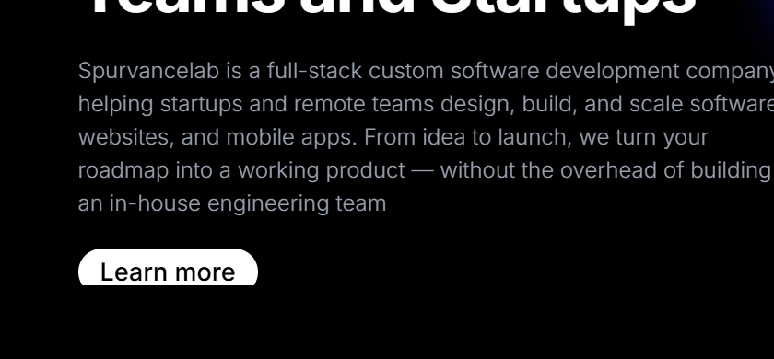

UX-002 - Introducing Cyber Community Pakistan
Type: UX
Section: Introducing Cyber Community Pakistan
Observation: The section introduces "Cyber Community Pakistan" without sufficient context, making it difficult for first-time visitors to understand its relationship with the company.
Recommendation: Add a brief explanation describing what Cyber Community Pakistan is and how it relates to Spurvancelab.
Severity: Medium
Screenshot:


UX-003 - Workflow/Services
Type: UX
Section: Workflow/Services
Observation: The workflow highlights development technologies but does not communicate software testing/QA capabilities, which may leave visitors unaware of the company's complete service offerings.
Recommendation: If QA/Testing is one of the company's services, include it in the workflow or highlight it elsewhere on the landing page.
Severity: Low
Screenshot:
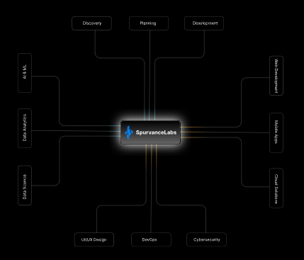

UI-003 - Trusted by Industry Leaders
Type: UI
Section: Trusted by Industry Leaders
Observation: The vertical spacing around the section appears inconsistent. The top padding is noticeably smaller than the bottom padding, making the section feel visually unbalanced.
Recommendation: Maintain consistent vertical spacing above and below the section to improve visual balance and design consistency.
Severity: Low
Screenshot:
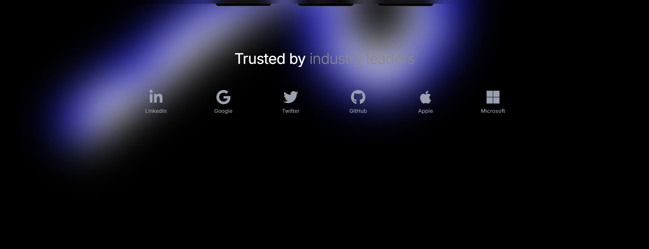

UX-004 - Our Services
Type: UX Recommendation
Section: Our Services
Observation: The "Learn More" text is clickable, but it does not stand out enough as a clickable element.
Recommendation: Use a more prominent design, such as a button or another clear visual cue, to make the CTA easier for users to notice.
Severity: Low
Screenshot:
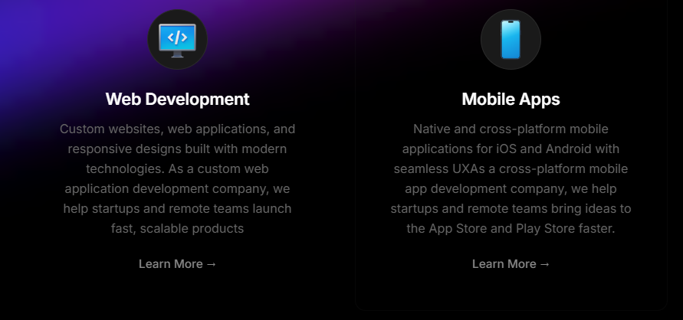

UX-004 - Why Choose Us
Type: UX
Section: Why Choose Us
Observation: The statistics (10+ Years Experience, 500+ Projects Completed, 98% Client Retention) are repeated even though similar information has already been presented in the "By the Numbers" section. This repetition increases the amount of content without providing additional value and may reduce user engagement.
Recommendation: Replace the repeated statistics with unique information or key differentiators to keep the content fresh and engaging.
Severity: Low
Screenshot:
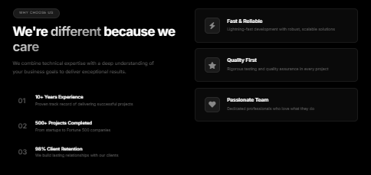

UI-006 - Why Choose Us
Type: UI
Section: Why Choose Us
Observation: The right side contains only three cards, making the layout appear slightly empty compared to the left side.
Recommendation: Consider adding a fourth card or adjusting the spacing and sizing of the existing cards to achieve better visual balance.
Severity: Low
Screenshot:


UI-005 - Why Choose Us
Type: UI
Section: Why Choose Us
Observation: The feature cards begin at the same vertical level as the heading, making the two-column layout appear slightly rigid.
Recommendation: Add a small top margin so the cards start slightly below the heading, creating a more balanced and visually appealing layout.
Severity: Low
Screenshot:


UI-010 - Our Network Ecosystem
Type: UI
Section: Our Network Ecosystem
Observation: The visual balance of the section appears inconsistent, as the image occupies significantly less space than the accompanying text, making the layout feel text-heavy.
Recommendation: Increase the image size or adjust the text layout to create a more balanced visual composition.
Severity: Low
Screenshot: 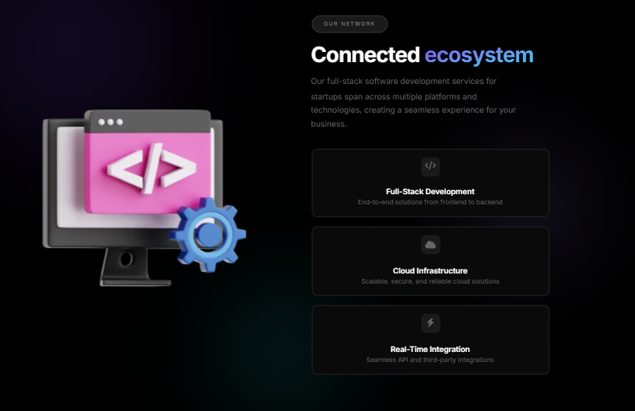

UX-012 - Testimonials
Type: UX
Section: Testimonials
Observation: The testimonials section displays multiple testimonials simultaneously, making the section appear visually dense and increasing the amount of information users need to process at once.
Recommendation: Consider presenting testimonials in a carousel or slider to reduce visual clutter and improve focus on individual customer feedback.
Severity: Low
Screenshot:
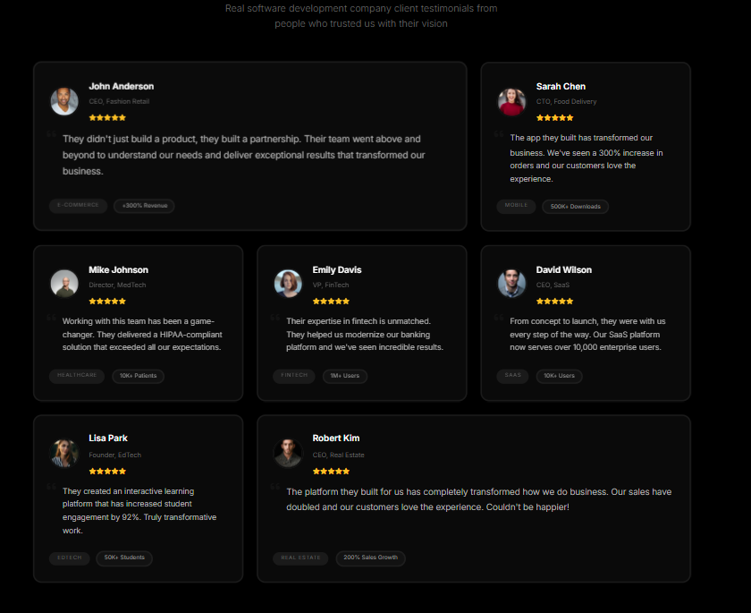

UI-013 - Contact Section
Type: UI
Section: Contact Section
Observation: The right-side contact information container appears noticeably smaller than the adjacent contact form, resulting in an unbalanced visual layout.
Recommendation: Increase the width or overall size of the right-side container to create a more balanced and visually appealing layout.
Severity: Low
Screenshot:
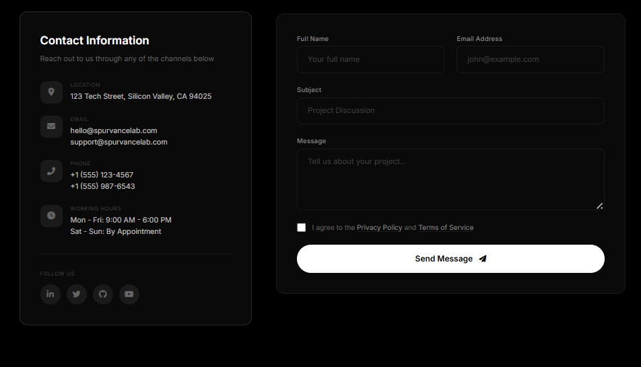

UX-014 - Overall Landing Page
Type: UX
Section: Overall Landing Page
Observation: The landing page contains a large amount of content and multiple lengthy sections, which may increase cognitive load and reduce user engagement as users need to scroll extensively to reach the end of the page.
Recommendation: Consider simplifying the content, reducing unnecessary text, and prioritizing key information to create a more focused and engaging user experience.
Severity: Medium
SERVICES

UI-001 - Hero
Type: UI
Section: Hero
Observation: The hero heading occupies a relatively narrow width, leaving significant unused space on both sides, which makes the layout feel less balanced.
Recommendation: Increase the heading container width or optimize the layout to utilize the available horizontal space more effectively.
Severity: Low
Screenshot:
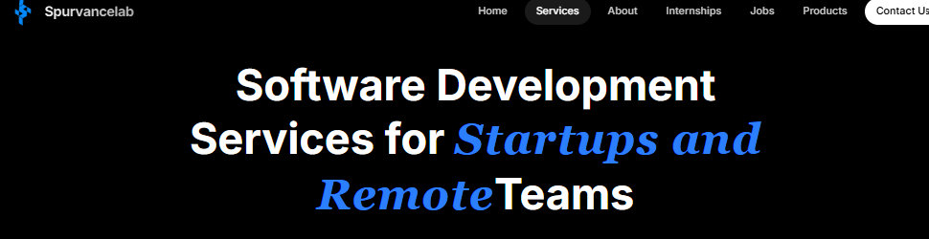

UX-001 - Hero Cards
Type: UX
Section: Hero Cards
Observation: The overlapping card layout makes the background cards difficult to notice, as there is no visual cue indicating that multiple cards are available.
Recommendation: Add a visual indicator or interaction (e.g., carousel, animation, or partial card preview) to improve discoverability.
Severity: Medium
Screenshot:
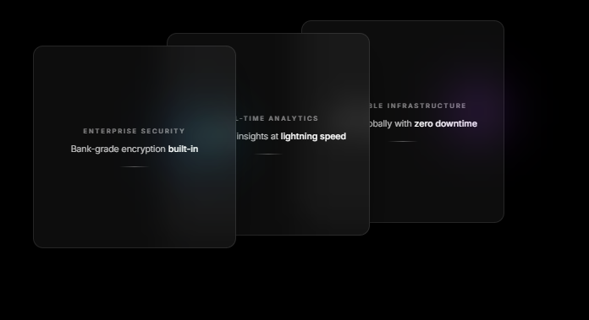

UX-002 - What We Offer
Type: UX
Section: What We Offer
Observation: The service cards contain lengthy descriptions, making the section appear text-heavy and reducing content scannability.
Recommendation: Keep descriptions concise or provide a "Read More" option to improve readability and user engagement.
Severity: Medium
Screenshot:
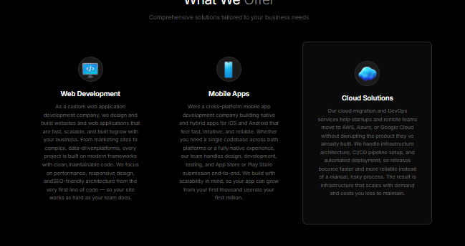
ABOUT

UX-001 - About Page
Type: UX
Section: About Page
Observation: The About page lacks sufficient company information and does not clearly communicate the company's identity to visitors.
Recommendation: Add a detailed company introduction section before the Teams section covering mission, vision, values, and background.
Severity: Medium

INTERNSHP

UX-002 - Hero Section
Type: UX
Section: Hero Section
Observation: The hero section contains excessive text, which makes the section feel crowded and reduces the user's ability to quickly understand the main purpose of the internship page.
Recommendation: Reduce the amount of text and keep the hero content focused on key information such as internship opportunities, benefits, and a clear call-to-action to improve readability and user engagement.
Severity: Medium
Screenshot:

JOBS

UI-001 - Find Your Jobs (Search Bar)
Type: UI
Section: Find Your Jobs (Search Bar)
Observation: The search icon inside the search bar is placed too close to the left edge, making the input field appear visually cramped and reducing overall alignment consistency.
Recommendation: Add appropriate left padding/margin between the icon and the input field to create better spacing and improve visual balance.
Severity: Low
Screenshot:
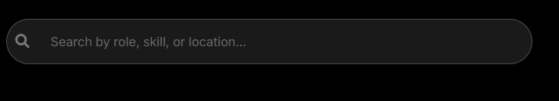
PRODUCTS

UX-001 - Hero
Type: UX
Section: Hero
Observation: The hero section appears visually crowded due to the amount of content displayed at once, reducing readability and making it difficult for users to focus on the primary message.
Recommendation: Simplify the hero section by reducing unnecessary content and emphasizing the key message and primary CTA.
Severity: Medium
Screenshot:
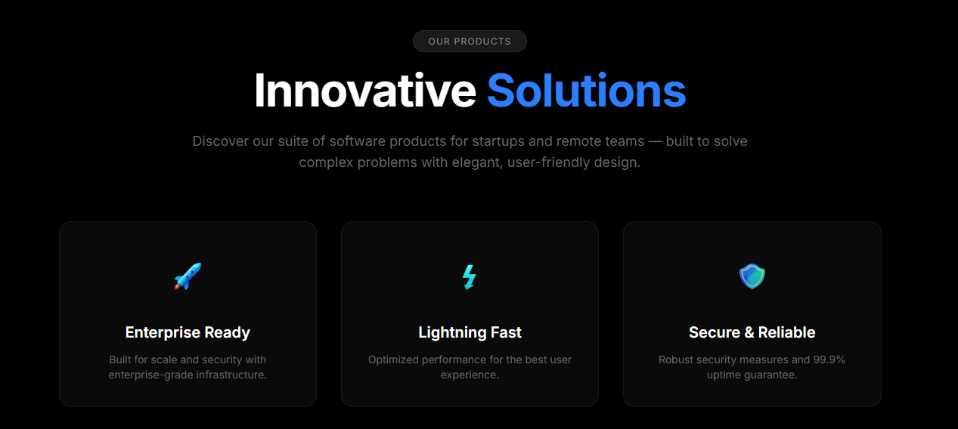

UI-002 - Hero
Type: UI
Section: Hero
Observation: The "Our Products" pill at the top does not contribute meaningful value and appears visually unnecessary.
Recommendation: Remove the "Our Products" pill to create a cleaner and more focused hero section.
Severity: Low
Screenshot:


UI-003 - Hero
Type: UI
Section: Hero
Observation: The three informational cards below the hero content make the section feel overcrowded and visually heavy.
Recommendation: Remove or relocate the cards to another section to improve visual hierarchy and reduce clutter.
Severity: Medium
Screenshot:


UI-004 - Products
Type: UI
Section: Products
Observation: The product cards are relatively tall due to lengthy content and spacing, making the section appear text-heavy.
Recommendation: Reduce the card height by optimizing spacing and keeping the content more concise for better scannability.
Severity: Low
Screenshot:
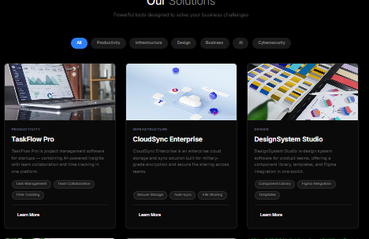
CONTACT

UI-001 - Contact Hero
Type: UI
Section: Contact Hero
Observation: The light/glow effect behind the text on the left side is visually distracting and reduces text comfort, making the section slightly harsh on the eyes.
Recommendation: Remove or reduce the background glow effect behind the text to improve readability and create a cleaner visual appearance.
Severity: Low
Screenshot:
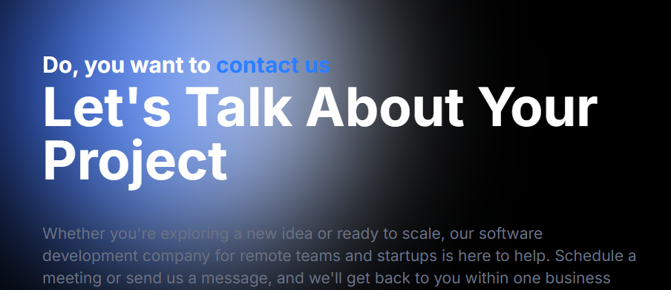

UI-002 - Contact Information Section
Type: UI
Section: Contact Information Section
Observation: The text inside the right-side contact information container is positioned too close to the left edge, making the content appear cramped and reducing visual balance.
Recommendation: Increase the left padding inside the container to provide adequate spacing and improve readability and overall alignment.
Severity: Low
Screenshot:


RESPONSIVENESS

RWD-001 - Hero (Mobile View)
Type: Responsive UI
Section: Hero (Mobile View)
Observation: The hero section content is not properly center-aligned on mobile screens, resulting in an unbalanced layout.
Recommendation: Center-align the hero content and ensure consistent alignment across all mobile screen sizes.
Severity: Medium
Screenshot:
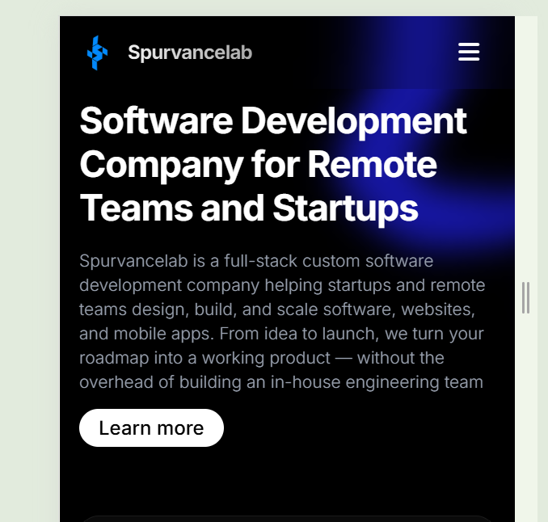

RWD-002 - Workflow (Mobile View)
Type: Responsive UI
Section: Workflow (Mobile View)
Observation: The Workflow section content appears too close to the left and right edges on mobile screens, leaving insufficient horizontal padding.
Recommendation: Add consistent horizontal padding to improve readability and maintain a balanced responsive layout.
Severity: Medium
Screenshot:
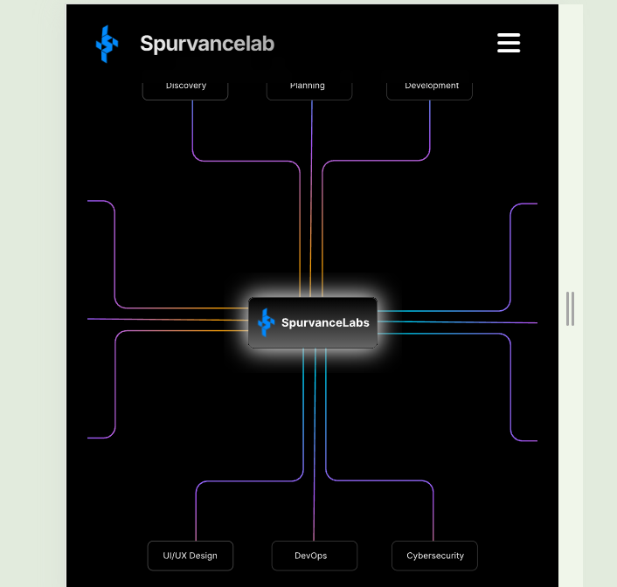

RWD-003 - Why Choose Us (Mobile View)
Type: Responsive UI
Section: Why Choose Us (Mobile View)
Observation: The content alignment in the Why Choose Us section appears inconsistent on mobile screens.
Recommendation: Center-align the section content and maintain consistent spacing for better visual balance.
Severity: Low
Screenshot:
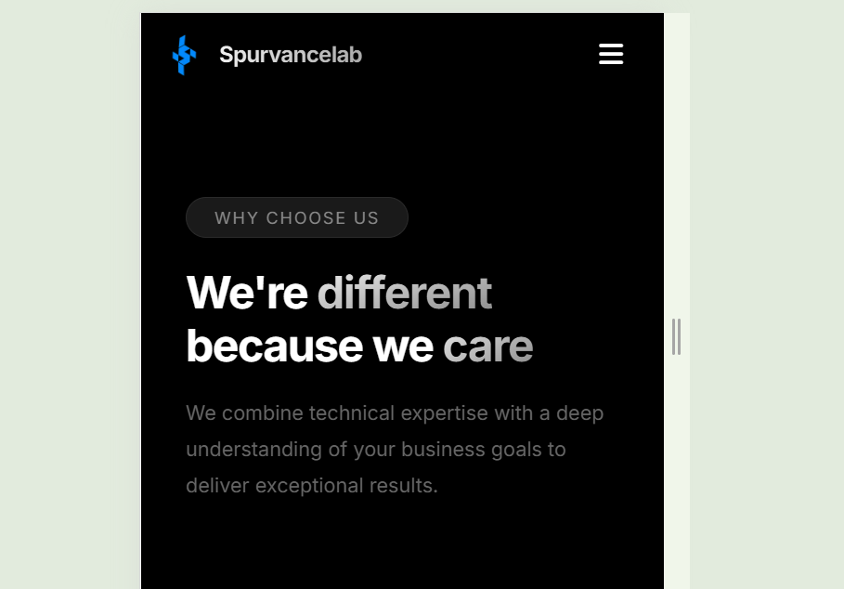

RWD-004 - Featured Projects (Mobile View)
Type: Responsive UI
Section: Featured Projects (Mobile View)
Observation: The Featured Projects carousel/cards appear overly stretched on mobile screens, making the layout look disproportionate.
Recommendation: Optimize the carousel and card dimensions for mobile devices to improve visual balance and usability.
Severity: Medium
Screenshot:
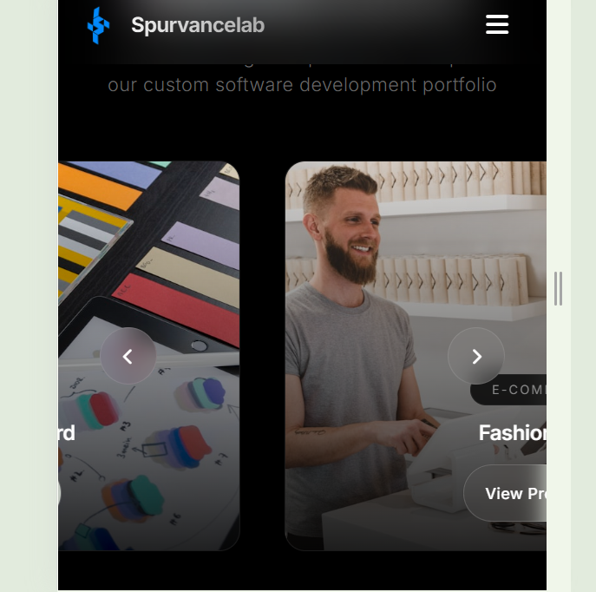

RWD-T001 - Hero (Tablet View)
Type: Responsive UI
Section: Hero (Tablet View)
Observation: The hero section content is positioned too close to the left side on tablet screens, resulting in an unbalanced layout.
Recommendation: Add appropriate horizontal spacing and align the hero content properly to create a balanced layout on tablet devices.
Severity: Medium
Screenshot:
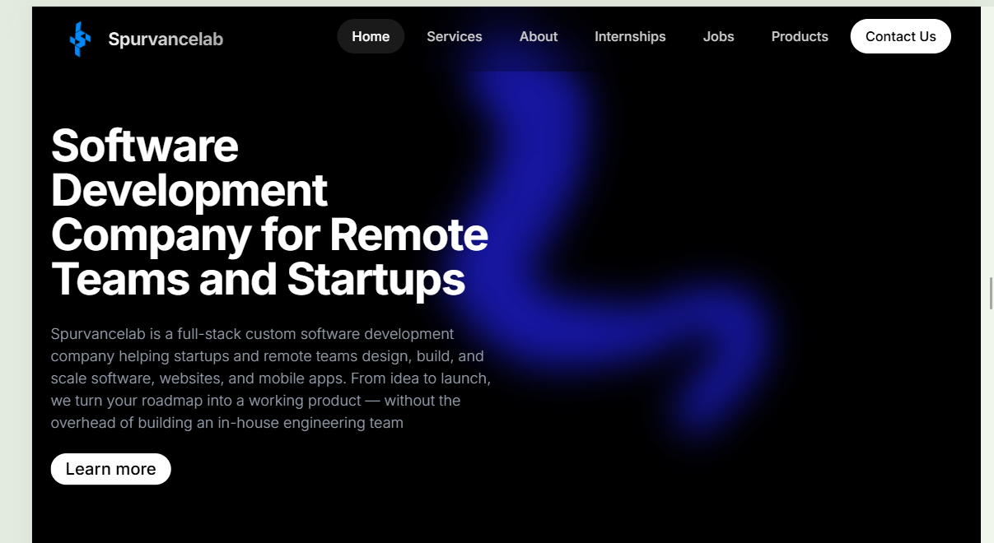

RWD-T002 - Workflow (Tablet View)
Type: Responsive UI
Section: Workflow (Tablet View)
Observation: The Workflow section content appears too close to the left and right edges on tablet screens, leaving insufficient horizontal padding.
Recommendation: Increase the left and right padding to improve readability and maintain consistent spacing across tablet layouts.
Severity: Medium
Screenshot:
